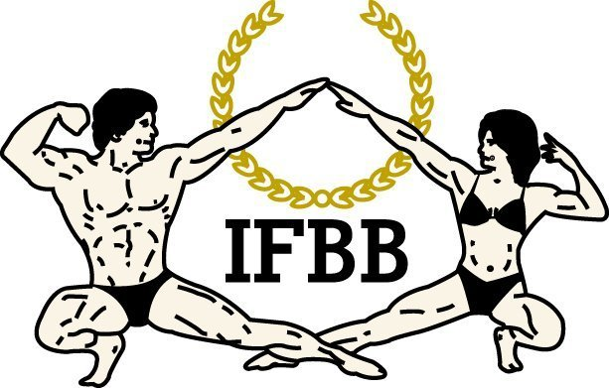
Organiser
Mike Debenham
DFS Promotions
PO Box 3152
Christchurch
M: 021 885 212
E: mike@debenhamfitness.co.nz

AUSTRALASIAN/SOUTH PACIFIC

IFBB Membership & Registration Form

South Island Bodybuilding Figure and Bikini Championships

Affiliated With: International Federation of Body Builders (IFBB)

First Name: | Surname: | Date of Birth:
Address: | Suburb: | City:
Home Ph: | Mobile Ph: | Email:

Event: South Island Championships | Annual Membership Joining Fee: $45.00
Event Date: 25th September 2010 | Event Entry Fee: $30.00/ late entry $40.00

 | Category Selection | ☑ | Approved |  | Category Selection | ☑ | Approved
1 | Teenage Men  18yrs – up to 31st Dec |  |  | 17 | Women’s Bikini
2 | Junior Men  21yrs – up to 31st Dec |  |  | 18 | Novice Body Figure Short  Under 164cm (old figure)
3 | Masters Men  40yrs – Incl from 1st Jan |  |  | 19 | Novice Body Figure Tall  Over 164cm (old Figure)
4 | Masters Men  50yrs / 60yrs– Incl from 1st Jan |  |  | 20 | Novice Figure Short  Novice Under 164cm
5 | Masters Women  35yrs – Incl from 1st Jan |  |  | 21 | Novice Figure Tall  Novice Over 164cm
6 | Masters Women  45yrs – Incl from1st Jan |  |  | 22 | Open Body Figure Short  Under 164cm
7 | Senior Body Figure 35yrs  Incl from 1st Jan |  |  | 23 | Open Body Figure Tall  Over 164cm
8 | Senior Body Figure 45yrs  Incl from 1st Jan |  |  | 24 | Open Women’s  Up to & including 55kg
9 | Junior Women  21yrs – Up to 31st Dec |  |  | 25 | Open Women’s  Over 55kg
10 | Novice Women  Up to & including 55kg |  |  | 26 | Open Figure Short  Under 164cm
11 | Novice Women  Over/55kg |  |  | 27 | Open Figure Tall  Over 164cm
12 | Novice Men  Under 70kg |  |  | 28 | Open Men  Under & including 70kg
13 | Novice Men  70-80kg |  |  | 29 | Open Men  70-80kg
14 | Novice Men  Over 80kg |  |  | 30 | Open Men  80-90kg
15 | Mixed Pairs / Couples  (Bodybuilding rules Apply) |  |  | 31 | Open Men  Over 90kg
16 | Mens Classic  (Height vs Weight Ratio)

Registration, Entry, IFBB Championship Drug Testing Consent, Declaration and Oath Release Form
As a condition of competing in this event, I the undersigned athlete do hereby agree to be bound by the IFBB Constitution and Rules, Code of Ethics and the Anti-Doping Program. I further agree to co-operate fully with the IFBB and the event organiser. I understand and agree to the following conditions:
1. I agree that the Judges decision is final
2. I agree to abide by the constitution and rules of the IFBB
3. I give permission for any media coverage of my appearance in relation to this even, if such coverage is approved by the IFBB Executive
4. That IFBB New Zealand has the right to conduct random and/or compulsory drug testing at this event
5. That if I’m selected for drug testing, I will co-operate fully with the drug testing officers at all times and will, under the direct observation of a witness, provide a sample of my urine without delay.
6. That if I’m subsequently found guilty of doping offence, I will respect and abide by the relevant rules and regulations governing results management, including those pertaining to the appeal process.
7. That I accept sole responsibility to remain current with the Rules & Regulations governing this event, including those pertaining to drug testing and results management.
8. That I do hereby declare and make oath that I am competing in this even free from prohibited performance enhancing drugs.

Special Declaration:
I wish to be considered for eligibility to represent New Zealand at IFBB International / World Events.
__________________ (signature)
___________________________ ______________________
Signature of Competitor Date

___________________________ ______________________
Signature of Parent/Guardian if available Date
(if competitor is under 18 years of age)

